Booking Information
Available to hire:
Sunday to Friday 8am - 10pm
Saturday & Sunday 8am – 6pm
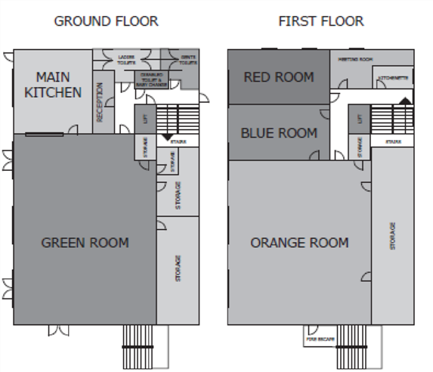
GROUND FLOOR
The Green room [13.6 x 9.6m] has vinyl flooring, French doors onto a secure garden. Use of the kitchen included which has a water boiler, hob, double oven and fridge freezer. Ladies, gents and disabled toilets on the ground floor. Baby changing facilities in disabled toilet.
FIRST FLOOR - accessible by lift and stairs:
All rooms have use of kitchenette with tea / coffee making facilities and washing up. Red & Blue room [both 4.7 x 6.4m] are carpeted and suited to training and meetings. Orange room [10 x 9.6m] has vinyl flooring suitable for large meetings. Latte room is more intimate and suited to interviews, consultations.

Business Prices
Room | Maximum capacities in each style | Rate per hour
Green | 150 conference (chairs only), approx. 100 with tables (dependent on layout) | £20
Orange | 110 conference (chairs only), approx. 90 with tables (dependent on layout) | £18
Red | 30 conference (chairs only) , 15 boardroom (around tables) | £15
Blue | 30 conference (chairs only) , 15 boardroom (around tables) | £15
Latte | 8 boardroom (around tables) | £10
- Please allow for your set-up and cleaning up in your booking times.
- Your arrival and departure time must be adhered to. You will be charged at the appropriate rate for any additional rooms you use and or if you access your room earlier than booked or stay over your booked time.
- When you book, please allow time for setting up and packing away. You will not be able to access a room before the booking time to set up. You will also be charged if you stay in a room after your booking to pack away.
- If facilities are not left clean, equipment and/or rooms are damaged, a fee will be levied. This includes removing left over food, washing, and putting away dishes.
- Please advise your delegates to use our car park whilst visiting the Centre. There are also unreserved bays at the front of the Centre, but please respect our neighbours’ designated spaces.
- - You will be invoiced at the end of the month. Payment can be made by cash, cheque or BACS payable to Newcourt Community Association, sort code: 55-61-44, Account number: 72542276

Name of organiser
Name of Group | Number of people:
Purpose of hire

Booking Form for business events
Note: If booking a series of dates please fill in a separate form for each date or list all dates required clearly.
Room required |  | Choose an item.
Date required |  | Click or tap to enter a date.
Title: |  | Enter course / event title as it should appear on directional sign for arriving delegates
Time of arrival: | Departure: |  |  | Total hours:
Invoicing address
Postcode
Email
Telephone / mobile
Purchase Order No.
Must be supplied
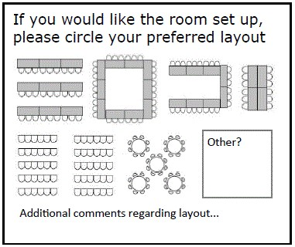 | Tick Item To pay  ☐ Room hire  ☐ Room set up £10 £10.00  ☐ Tea/ coffee/ biscuits @ £1.50 per head per day  ☐ Digital projector and trolley £40 per day  ☐ Flip chart stand *no paper supplied* 0  Total to pay £
I have read, understand and agree to the room hire terms and conditions. Please print your name and sign below. The return to: Newcourt Community Centre, Blakeslee Drive, Exeter, EX2 7FN.
SIGN
PRINT
Enquiries: T: 01392 873560 E: info@newcourtcommunitycentre.com W: www.newcourtcommunitycentre.com

